Data Structure and Algorithm

Laboratory Activity No. 4

Arrays

|  |  |
| --- | --- |
| *Submitted by:* | *Instructor:* |
| Ramos, Jan Lawrence M. | Engr. Maria Rizette H. Sayo |

August 16, 2025

# Objectives

Introduction

Array, in general, refers to an orderly arrangement of data elements. Array is a type of data structure that stores data elements in adjacent locations. Array is considered as linear data structure that stores elements of same data types. Hence, it is also called as a linear homogenous data structure.

This laboratory activity aims to implement the principles and techniques in:

* Writing algorithms using Array data structure
* Solve programming problems using dynamic memory allocation, arrays and pointers

# Methods

Jenna’s Grocery

N

Jenna wants to buy the following fruits and vegetables for her daily consumption. However, she needs to distinguish between fruit and vegetable, as well as calculate the sum of prices that she has to pay in total.

Problem 1: Create a class for the fruit and the vegetable classes. Each class must have a constructor, deconstructor, copy constructor and copy assignment operator. They must also have all relevant attributes (such as name, in the problem price and quantity) and functions (such as calculate sum) as presented description above.

Problem 2: Create an array GroceryList in the driver code that will contain all items in Jenna’s Grocery List. You must then access each saved instance and display all details about the items.

Problem 3: Create a function TotalSum that will calculate the sum of all objects listed in Jenna’s Grocery List.

Problem 4: Delete the Lettuce from Jenna’s GroceryList list and de-allocate the memory assigned.

# Results

**Algorithm for Jenna’s Grocery Program**

1. **Start**
   * Begin program execution
2. **Initialize Grocery List**
   * Create list with 4 items:
     + Apple (Fruit, PHP 10, 7)
     + Banana (Fruit, PHP 10, 8)
     + Broccoli (Vegetable, PHP 60, 12)
     + Lettuce (Vegetable, PHP 50, 10)
3. **Display Initial List**
   * Print header "== JENNA'S GROCERY LIST =="
   * For each item, display:
     + Type, Name, Price, Quantity, Total
4. **Calculate Total Sum**
   * Sum all item totals (price × quantity)
   * Display "Total Sum of Grocery List: PHP X"
5. **Remove Item Decision**
   * Check if "Lettuce" exists in list
   * If found:
     + Remove from list
     + Print "Removing Lettuce from the list"
   * If not found:
     + Print error message
6. **Display Updated List**
   * Print header "== UPDATED GROCERY LIST =="
   * Display remaining items
7. **Calculate New Total**
   * Recalculate sum without removed item
   * Display "Total Sum of Grocery List: PHP Y"
8. **End**

**Source code**

. 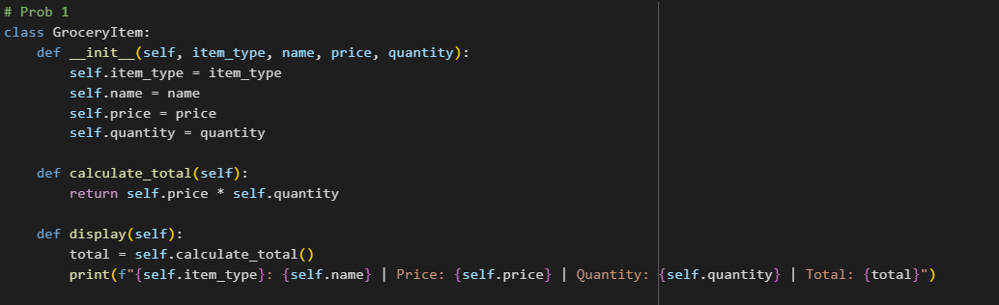

**OUTPUI**

# Conclusion

This lab activity helped me understand arrays and object-oriented programming better. By making classes for fruits and vegetables, I learned how to use constructors, destructors, copy, and assignment methods in a simple program. I also practiced calculating totals and removing items from a list, which showed me how these concepts work in real-life situations like managing groceries. Overall, this activity improved my knowledge of arrays and algorithms.

**References**

[1]GeeksforGeeks, "Arrays in Data Structures," [Online]. Available: https://www.geeksforgeeks.org/array-data-structure/.